**Radio button in HTML**

1. Line 17 19 21 inside input type attribute set to radio
2. Line 17 19 21 name attribute should have the same value in order to select one button out of many.
3. Line 17 19 21 value attribute needs to be defined which will required at server side

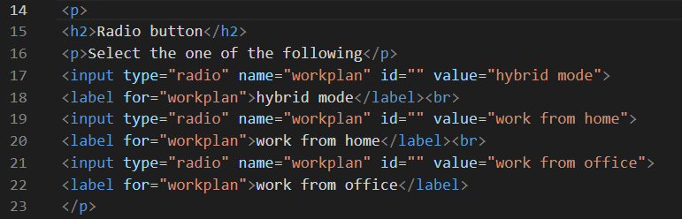

**Checkbox in HTML**

1. Line 27 type attribute set to checkbox.
2. Line 27 name attribute is used to link the checkbox with the label.

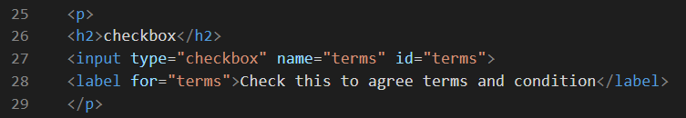

**Select box in HTML**

1. Below is the demo of checkbox.

